

**MATHEMATICS  
APPLICATIONS**

**Test 1 – Data Analysis and Linear Models**

**Chapters 1 and 2**

**Semester 1 2018**

**Section One - Calculator Free**

Time allowed for this section

Working time for this section: 25 minutes

Marks available: 27 marks

## Material required/recommended for this section

##### To be provided by the supervisor

This Question/Answer booklet

Formula sheet

##### To be provided by the candidate

Standard items: pens, pencils, pencil sharpener, eraser, correction fluid, ruler, highlighters

Special items: Nil

## Important note to candidates

No other items may be used in this section of the examination. It is **your** responsibility to ensure that you do not have any unauthorised notes or other items of a non-personal nature in the examination room. If you have any unauthorised material with you, hand it to the supervisor **before** reading any further.

1. (7 marks)  
   Before a fitness campaign at a high school, 50 students were chosen at random from each year group and asked the following questions:

Question 1: Which one of the following modes of transport do you use to travel to and from school?  
  
Category A: walking/cycling  
Category B: public transport  
Category C: private car

Question 2: Which year group are you in?

The campaign organisers wished to determine whether age group affected the students’ likelihood of walking/cycling to and from school.

The results of the survey are shown in the table below.

|  |  |  |  |  |
| --- | --- | --- | --- | --- |
|  | **Category A** | **Category B** | **Category C** | **Total** |
| **Year 7** | 19 |  | 20 | 50 |
| **Year 8** | 12 | 17 | 21 | 50 |
| **Year 9** | 13 | 14 | 23 | 50 |
| **Year 10** | 11 |  | 21 |  |
| **Year 11** | 10 | 15 | 25 | 50 |
| **Year 12** | 8 | 17 | 25 | 50 |
| **Total** | 73 |  | 135 | 300 |

1. Complete the missing entries in the table above. [2]
2. Compare the percentages of students in Year 7 and Year 12 who use Category A as a mode of transport and comment on your results. [2]

The data given in the table in part a. have been displayed as a divided column graph below.

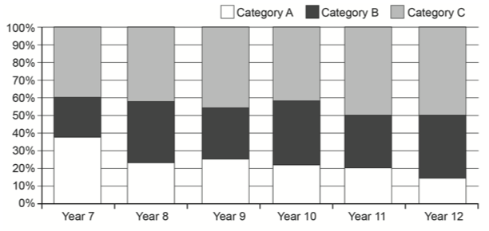

1. Using the graph above or another method, comment on:

i. the association between ‘Year group’ and ‘Category A’. [1]

ii. the association between ‘Year group’ and ‘Category C’. [1]

iii. the association between ‘Category A’ and ‘Category B and C combined’. [1]

1. (15 marks)  
   The marks for Chemistry and Physics tests (out of 10) were recorded in the table below for 7 students:

|  |  |  |  |  |  |  |  |  |
| --- | --- | --- | --- | --- | --- | --- | --- | --- |
|  | Chemistry (x) | 3 | 4 | 5 | 6 | 7 | 9 | 9 |
|  | Physics (*y*) | 2 | 4.5 | 4 | 6 | Absent | 7 | 8 |

1. Draw a scatterplot to represent this information. [3]



1. Describe the strength and direction of the association. [2]
2. Draw the line of best fit ‘by eye’ and hence estimate a Physics mark for the student who was unable to sit that test (to the nearest half mark). [2]

The ‘Line of Best Fit’ equation for the association is: y = 0.8x + 0.4

1. Complete the table of residuals to 1 d.p. [4]

|  |  |  |  |  |  |  |  |
| --- | --- | --- | --- | --- | --- | --- | --- |
|  | Chemistry (x) | 3 | 4 | 5 | 6 | 9 | 9 |
|  | Physics (*y*) | 2 | 4.5 | 4 | 6 | 7 | 8 |
|  | Predicted Physics | 2.8 |  |  |  |  | 7.6 |
|  | Residual | -0.8 |  |  |  |  | 0.4 |

1. Draw a residual plot. [2]



1. Using the residual plot as a reference, decide if the data being investigated is linear or non-linear. [2]
2. (5 marks)  
   The worldwide consumption of coal (in billion tonnes of oil equivalent, BTOE) is shown in the graph below from 1965 until 2010.   
     
   
3. Add a trend line, by eye, to the scatterplot. [1]
4. Estimate the worldwide consumption of coal in

(i) 1960. [1]

(ii) 2030. [1]

1. Which estimate in (c) is more reliable? Explain your reasoning. [2]

**End of Section One**